The compatibility of wildflower meadow areas and
wildfire risk in Petersfield parish

Andy J Moffat¹ and Melanie Oxley²
¹ andy.moffat@petersfieldsociety.org.uk; ² melanieoxley44@gmail.com

May 2023
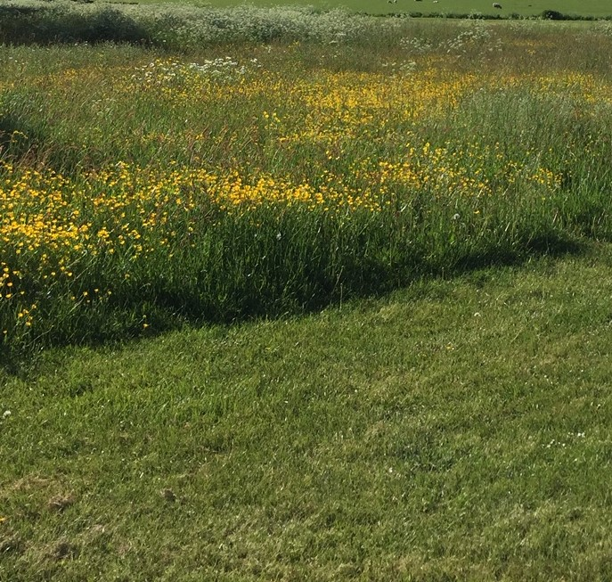
The compatibility of wildflower meadow areas and
wildfire risk in Petersfield parish

Introduction
In the 2020s, it is more apparent than ever that Britain needs to retain, protect and increase its wildflower meadows. Kew Gardens suggests that our country has lost 97% of wildflower meadows since the 1930s and that wildflowers are “crucial for pollinators, plants and people”. As a consequence there are several active national programmes which encourage communities to replace lost wildflower areas and/or to create new ones (e.g. GrowWild, Plantlife and Wildlife Trusts). To celebrate the coronation of His Majesty King Charles III, English Heritage will be enhancing and creating one hundred meadows at its castles, abbeys, prehistoric stone circles and palaces, including many in urban areas.
In towns like Alton and Petersfield, there has been strong support for actions of this kind, and in the former there has already been purposeful action to create new meadow areas on public greenspace. The Petersfield Society’s Valuable Verges Open Forum in May 2021 attracted a large number of delegates and excitement amongst the community. Since then, both the Petersfield Society and PeCAN have encouraged the town to do more to create wildflower areas. In its Climate Action Plan, Petersfield Town Council responded by stating its intention “to create & restore habitats encouraging biodiversity on the green spaces” it owns and manages on behalf of the community. Such proposals solidify the policies for biodiversity enhancement contained in Petersfield’s Neighbourhood Plan (2015).

In June, July and August 2022, many parts of Britain suffered from a prolonged period of dry weather, including several ‘heatwaves’. 2022 was the hottest year on record in the UK. At a national level, risk of wildfire to certain types of vegetation was increased, and fires broke out at several locations in the country, for example locally at Bisley Ranges in Surrey and Yateley Common in Hampshire. Fortunately, no wildfires were recorded in Petersfield parish in 2022, but a decision was made to intervene and cut back grass verges at some locations, such as Ramshill Estate where they had been left unmown during May in accordance with the national ‘No Mow May’ campaign. Subsequently, the Head of Grounds Committee asserted at Grounds Committee meetings and at the Town Meeting on 8th March 2023 that she has concerns about the establishment of new wildflower areas because of the risk of ignition and wildfire spread. As a result, proposals to establish small areas of wildflower meadow at two greenspace sites put forward in November 2022 by the Petersfield Society for consideration by Grounds Committee have been rejected.
This paper seeks to find an evidenced-based resolution to the predicament that the decision above poses – if taken forward across the parish without modification, it runs in contravention to the Climate Action Plan and Neighbourhood Plan and would restrict the community’s desire to support wildlife. However, it is recognised that the risk of wildfire is greater now as a result of climate change and that this risk needs to be factored into grounds management procedures for the town’s greenspaces.

The risk of wildflower meadow ignition
The two wildflower meadow areas proposed for Petersfield referred to above were considered as substitutes for existing areas of grassland, and to be composed of a range of wildflower species. The Wildlife Trusts suggest that there are two main methods for establishing such meadows (a) let existing grass grow long (don’t mow until July or August) and wait for wildflower seed to arrive by natural colonisation, and then germinate and establish. Alternatively, (b) it is possible to remove the grass turf by digging it up and then seed the site with appropriate meadow species. Already established meadow turf may also be used, but it is a comparatively expensive method.
When considering wildfire risk, the combustibility of the type of vegetation cover should be considered compared to the alternatives that might already be present. If possible, ‘fire resistant’ vegetation types should be chosen in place of any that are known to be particularly flammable. Useful information on the relative combustibility of different forms of vegetation comes from a recent study on wildfire occurrence in nearby area on the borders of Hampshire, Surrey and Berkshire. Here nearly 1000 actual wildfire records collected over a four year period by the Fire & Rescue Service were classified according to land-use (Table 1). Table 1 shows the ‘Risk of Ignition’ according to a five category system, from Very Low (score 1) to Very High (score 5). It shows that based on real data, some forms of vegetation such as heather grassland are comparatively flammable, whilst others such as grass and ‘other vegetation’ carry a very low risk. Taken as a whole, the Table suggests that wildflower meadow creation using both the methods described above is comparatively safe. However, it might be advisable to make a summer cut in newly establishing meadow areas, with the arisings being carried away from the site. The accepted practice of “cut & collect” in the management of such areas reduces the potential of dry arisings to become fuel for wildfires.
There is a lot of guidance from America that can help in the choice of fire-resistant species for new wildflower meadows. Further American guidance can also help in the design of wildflower areas. This suggests that near dwellings, fire resistance is aided by:
- designing plantings to be more widely spaced and lower growing than those further away;
- planting in small, irregular clusters or islands separated by breaks;
- incorporating a diversity of plant types and species in the landscape;
- using mulches to conserve moisture and reduce weed growth.

Table 1. Comparison of relative Risk of Ignition scores for land cover types using method based on Fire and Rescue Service data for all vegetation fires for financial years 2009/10 to 2012/13.
Score 1 = Very Low, Score 5 = Very High

Land cover type
 | Risk of Ignition score
1. Broadleaved | 3
2. Coniferous | 3
3. Felled | 2
4. Ground prepared for new planting | 5
5. Mixed – predominantly Broadleaved | 5
6. Mixed – predominantly Conifer | 4
7. Young trees | 4
8. Low density | 1
9. Assumed woodland | 1
10. Shrub land | 1
11. Grass | 2
12. Agricultural land | 3
13. Other vegetation | 1
14. Bare ground/rock | 2
15. Urban/building | 3
16. Quarry | 5
17. Powerline | 1
18. Forest road or track | 1
19. Heather | 2
20. Heather grassland | 4

(from McMorrow et al., 2021)

American advice on ‘fire resistant landscaping’ is to purposely establish areas of wildflower meadows in areas of housing, but leaving a meadow-free zone of five feet (1.5 metres) around properties. Other authoritative American advice for semi-arid areas in Utah states: “Furthermore, wildflower meadows could serve as an important buffer against wildfires at the urban-wildland interface”. This implies that the authorities there don’t regard wildflower meadow as a risk, but instead see it as a way to prevent wildfire spread.

Conclusions
American research and experience in managing wildflower meadows in regions prone to wildfire suggest that this can be done without undue risk provided that wildflower areas are managed with regard to fire hazard, i.e. arisings are removed from site. Following these principles, establishment of wildflower meadow is seen as providing a low risk of ignition and this is borne out by British data from the Home Counties. Indeed, Surrey Heath Borough Council, with considerable heathland vegetation cover close to the study area referred to above, makes it clear to residents that it doesn’t regard areas of wildflowers and long grasses as creating a fire hazard, if proper guidance is followed.
We recommend that Petersfield Town Council continues to follow the policy on biodiversity enhancement by establishing new wildflower meadows as appropriate, following the ambitions set out in its Climate Action Plan, and best practice as laid out in the publications and guidance referred to in this report. It should suspend any policies to the contrary as a matter of urgency so as to allow more meadows to develop in 2023. Opportunities should be taken to gain grants for wildflower establishment and management, for example the South Downs National Park Trust ‘Bee Lines’ project . In addition, in 2023 Petersfield could seek to emulate the English Heritage project by deliberately creating wildflower areas in commemoration of the coronation of King Charles III.
Based on recent local experience of wildfires and the research results summarised in Table 1, reducing fire risk will be of most importance on the small remaining heathland areas on Petersfield Heath. Preventative measures should be taken to reduce wildfire risk, including clear advice to the public, especially if further heatwaves are forecast.

Sources of information used in this report
Allen, P.S. and Brown, A.J. 2021. Sub-alpine wildflower meadows as a template for water-conserving landscape design in the western United States. ISHS Acta Horticulturae 1345: VIII International Conference on Landscape and Urban Horticulture, 197-204. https://www.actahort.org/books/1345/1345_26.htm
Dennis, F.C. 1999. Fire-Resistant Landscaping. Colorado State University Cooperative Extension, Fact Sheet No. 6.303, 4 pp. https://extension.colostate.edu/docs/pubs/natres/06303.pdf
Detweiler, A.J. and Fitzgerald, S.A. 2006. Fire-Resistant Plants for Home Landscapes. Pacific Northwestern Publication 590. https://www.firefree.org/wp-content/uploads/2016/02/Fire-Resistant-Plants.pdf
Kiers, H. and Colvin, J. 2019. Going native. Designing for fire — homeowner guidelines and considerations for native planting. Grasslands, Summer 2019, 23-29. https://cnga.org/resources/Documents/Resources/Landscaping%20with%20Nature/Kiers%20and%20Colvin_Summer_2019.pdf
McMorrow, J.M., Kazmierczak, A., Aylen, J., Moffat, A.J., Morison, J.I.L. and Gazzard, R. 2021. Developing a risk assessment approach for forest fire at the rural-urban interface: potential of the Wildfire Threat Analysis framework for the UK. Quarterly Journal of Forestry 115(3), 161-167. https://doi.org/10.5281/zenodo.6949092
Skelly, J. and Smith, E. 2017. Choosing the Right Plants for Northern Nevada's High Fire Hazard Areas - Lake Tahoe Basin, Extension | University of Nevada, Reno, SP-17-01, 62 pp. https://naes.agnt.unr.edu/PMS/Pubs/2017-3448.pdf

Report authors
Andy Moffat is a geographer, soil scientist and forester. He began his research career with the Forestry Commission studying the interaction of trees in urban and peri-urban environments. He has led research projects on a variety of subjects relevant to arboricultural policy and practice, including trees and wildfire, air pollution, climate change, trees, drought and moisture abstraction, species suitability and social aspects. Andy has published widely, and is the author of nearly 90 peer reviewed papers, 40 Government publications, nearly 60 books, book chapters and published conference proceedings, nearly 90 web-based, out-reach, trade and other publications and 40 contract reports.
In 2013, Andy set up his own consultancy company, specialising in trees and the built environment. He is a Fellow of the Royal Geographical Association and of the British Society of Soil Science, and is a Member of the Institute of Chartered Foresters (ICF), the England & Wales Wildfire Forum and a past member of the EU Expert Group on Forest Fires. He enjoys Chartered Consultancy status from the ICF.
Melanie Oxley is an ecologist, botanist and lifelong environmental campaigner who has worked for a number of not-for-profit organisations, delivering campaigns including Planta Europa and The Peat Inquiry for Plantlife. She most recently worked for The Ecology Consultancy in London on ecology and species protection in the built environment.
Now retired, she devotes her knowledge and experience to local groups including the Petersfield Society (PfS), Petersfield Physic Garden and Merritts Meadow Nature Reserve. Her work as a PeCAN Trustee focuses on the biodiversity crisis and new approaches to green infrastructure, through planning and management interventions. Melanie spear-headed PeCAN’s Verges Campaign and is part of the Tree Location initiative for PfS, which will complement PeCAN's fruit tree planting.

https://www.kew.org/read-and-watch/meadows-matter
https://growwild.kew.org/
https://www.plantlife.org.uk/uk
https://www.wildlifetrusts.org/actions/how-grow-wild-patch-or-mini-meadow
https://www.english-heritage.org.uk/about-us/search-news/100-meadows/
https://drive.google.com/file/d/1sLlem1cxw85ppwoKbbRR7yFkjz2hdfYU/view?usp=sharing
https://www.petersfield-tc.gov.uk/wp-content/uploads/2019/02/20160101-PNP-Main-Plan-Final.pdf
https://www.metoffice.gov.uk/binaries/content/assets/metofficegovuk/pdf/weather/learn-about/uk-past-events/summaries/uk_monthly_climate_summary_annual_2022.pdf
https://www.getsurrey.co.uk/news/surrey-news/live-updates-fire-crews-tackle-24398724
https://www.hampshirelive.news/news/hampshire-news/new-figures-show-hampshire-record-7980614
https://www.plantlife.org.uk/nomowmay
https://www.wildlifetrusts.org/actions/how-grow-wild-patch-or-mini-meadow
https://doi.org/10.5281/zenodo.6949092
https://www.firefree.org/wp-content/uploads/2016/02/Fire-Resistant-Plants.pdf; https://naes.agnt.unr.edu/PMS/Pubs/2017-3448.pdf
https://extension.colostate.edu/docs/pubs/natres/06303.pdf
https://cnga.org/resources/Documents/Resources/Landscaping%20with%20Nature/Kiers%20and%20Colvin_Summer_2019.pdf
https://www.actahort.org/books/1345/1345_26.htm
https://www.surreyheath.gov.uk/residents/sport-leisure-parks/parks-playgrounds/wildflower-areas-and-long-grass-regimes/frequently
https://www.southdownstrust.org.uk/beelines/

